实验 15 PE格式可执行文件的制作
实验目的
- 掌握PE格式可执行文件的结构。
- 掌握PE格式可执行文件的设计原理。
- 掌握PE格式可执行文件的生成方法。
- 进一步熟悉debug、debug32的使用。
实验步骤
1、通过平台软件获得“hello.exe”的磁盘数据映像。
；第1扇区，文件头
00000000 4D 5A 90 00 03 00 00 00-04 00 00 00 FF FF 00 00 MZ..............
00000010 B8 00 00 00 00 00 00 00-40 00 00 00 00 00 00 00 ........@.......
00000020 00 00 00 00 00 00 00 00-00 00 00 00 00 00 00 00 ................
00000030 00 00 00 00 00 00 00 00-00 00 00 00 B0 00 00 00 ................
00000040 0E 1F BA 0E 00 B4 09 CD-21 B8 01 4C CD 21 54 68 ........!..L.!Th
00000050 69 73 20 70 72 6F 67 72-61 6D 20 63 61 6E 6E 6F is program canno
00000060 74 20 62 65 20 72 75 6E-20 69 6E 20 44 4F 53 20 t be run in DOS
00000070 6D 6F 64 65 2E 0D 0D 0A-24 00 00 00 00 00 00 00 mode....$.......
00000080 5D 5C 6D C1 19 3D 03 92-19 3D 03 92 19 3D 03 92 ]\m..=...=...=..
00000090 97 22 10 92 1E 3D 03 92-E5 1D 11 92 18 3D 03 92 ."...=.......=..
000000A0 52 69 63 68 19 3D 03 92-00 00 00 00 00 00 00 00 Rich.=..........
000000B0 50 45 00 00 4C 01 03 00-98 67 F8 51 00 00 00 00 PE..L....g.Q....
000000C0 00 00 00 00 E0 00 0F 01-0B 01 05 0C 00 02 00 00 ................
000000D0 00 04 00 00 00 00 00 00-00 10 00 00 00 10 00 00 ................
000000E0 00 20 00 00 00 00 40 00-00 10 00 00 00 02 00 00 . ....@.........
000000F0 04 00 00 00 00 00 00 00-04 00 00 00 00 00 00 00 ................
00000100 00 40 00 00 00 04 00 00-00 00 00 00 02 00 00 00 .@..............
00000110 00 00 10 00 00 10 00 00-00 00 10 00 00 10 00 00 ................
00000120 00 00 00 00 10 00 00 00-00 00 00 00 00 00 00 00 ................
00000130 10 20 00 00 3C 00 00 00-00 00 00 00 00 00 00 00 . ..<...........
00000140 00 00 00 00 00 00 00 00-00 00 00 00 00 00 00 00 ................
00000150 00 00 00 00 00 00 00 00-00 00 00 00 00 00 00 00 ................
00000160 00 00 00 00 00 00 00 00-00 00 00 00 00 00 00 00 ................
00000170 00 00 00 00 00 00 00 00-00 00 00 00 00 00 00 00 ................
00000180 00 00 00 00 00 00 00 00-00 20 00 00 10 00 00 00 ......... ......
00000190 00 00 00 00 00 00 00 00-00 00 00 00 00 00 00 00 ................
000001A0 00 00 00 00 00 00 00 00-2E 74 65 78 74 00 00 00 .........text...
000001B0 24 00 00 00 00 10 00 00-00 02 00 00 00 04 00 00 $...............
000001C0 00 00 00 00 00 00 00 00-00 00 00 00 20 00 00 60 ............ ..`
000001D0 2E 72 64 61 74 61 00 00-92 00 00 00 00 20 00 00 .rdata....... ..
000001E0 00 02 00 00 00 06 00 00-00 00 00 00 00 00 00 00 ................
000001F0 00 00 00 00 40 00 00 40-2E 64 61 74 61 00 00 00 ....@..@.data...
；第2扇区，文件头
00000200 0B 00 00 00 00 30 00 00-00 02 00 00 00 08 00 00 .....0..........
00000210 00 00 00 00 00 00 00 00-00 00 00 00 40 00 00 C0 ............@...
00000220 00 00 00 00 00 00 00 00-00 00 00 00 00 00 00 00 ................
...... (全零区域)
000003F0 00 00 00 00 00 00 00 00-00 00 00 00 00 00 00 00 ................
；第3扇区，.text段，程序运行入口点
00000400 6A 00 6A 00 68 00 30 40-00 6A 00 E8 08 00 00 00 j.j.h.0@.j......
00000410 6A 00 E8 07 00 00 00 CC-FF 25 08 20 40 00 FF 25 j........%. @..%
00000420 00 20 40 00 00 00 00 00-00 00 00 00 00 00 00 00 . @.............
00000430 00 00 00 00 00 00 00 00-00 00 00 00 00 00 00 00 ................
...... (全零区域)
000005F0 00 00 00 00 00 00 00 00-00 00 00 00 00 00 00 00 ................
；第4扇区，.rdata段
00000600 76 20 00 00 00 00 00 00-5C 20 00 00 00 00 00 00 v ......\ ......
00000610 54 20 00 00 00 00 00 00-00 00 00 00 6A 20 00 00 T ..........j ..
00000620 08 20 00 00 4C 20 00 00-00 00 00 00 00 00 00 00 . ..L ..........
00000630 84 20 00 00 00 20 00 00-00 00 00 00 00 00 00 00 . ... ..........
00000640 00 00 00 00 00 00 00 00-00 00 00 00 76 20 00 00 ............v ..
00000650 00 00 00 00 5C 20 00 00-00 00 00 00 B1 01 4D 65 ....\ ........Me
00000660 73 73 61 67 65 42 6F 78-41 00 75 73 65 72 33 32 ssageBoxA.user32
00000670 2E 64 6C 6C 00 00 9B 00-45 78 69 74 50 72 6F 63 .dll....ExitProc
00000680 65 73 73 00 6B 65 72 6E-65 6C 33 32 2E 64 6C 6C ess.kernel32.dll
00000690 00 00 00 00 00 00 00 00-00 00 00 00 00 00 00 00 ................
......(全零区域)
000007F0 00 00 00 00 00 00 00 00-00 00 00 00 00 00 00 00 ................
；第5扇区，.data段，GBK编码
00000800 48 65 6C 6C 6F 57 6F 72-6C 64 00 00 00 00 00 00 Hello......
...... (全零区域)
000009F0 00 00 00 00 00 00 00 00-00 00 00 00 00 00 00 00 ................
2、对获得的磁盘数据进行数据分析
2.1 DOS可执行文件头
图1是DOS可执行文件头的数据分析结果。
2.2 标准头
图2是标准头的数据分析结果。
2.3 可选头
图3至4是可选头的数据分析结果。
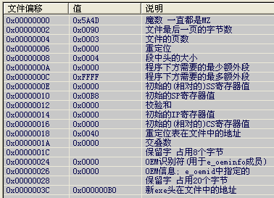
图1 DOS头结构分析
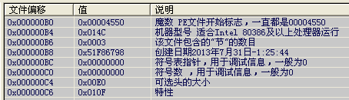
图2 标准头
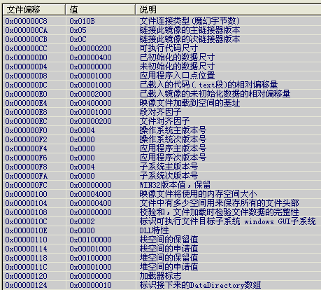
图3 可选头1
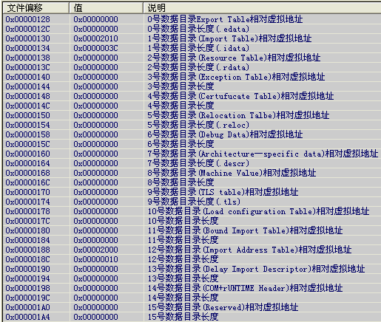
图4 可选头2
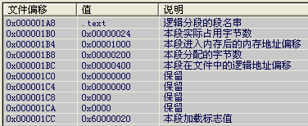
图5 .text段
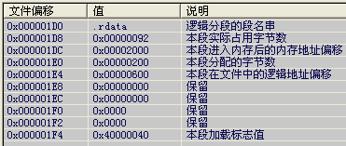
图6 .rdata段
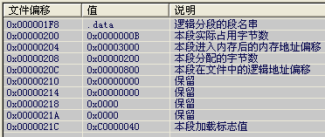
图7 .data段
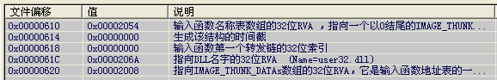
图8 user32.dll导入表及导入函数
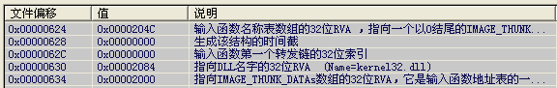
图9 kernal32.dll导入表及导入函数
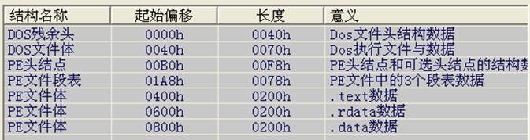
图10 hello.exe的磁盘存储结构
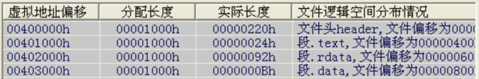
图11 hello.exe的内存运行结构
2.4 段表
图5至7是三个段的数据分析结果。
2.5 导入表
图8至9是导入表2个动态链接库的数据分析结果。
2.6 文件的内存加载与磁盘文件存储结构分析
图10是hello.exe的磁盘文件存储结构分析结果，而图11是hello.exe的内存加载数据分析结果。
3、加载hello.exe后内存逻辑空间数据映像分析。
；第1扇区，文件头
00400000 4D 5A 90 00 03 00 00 00-04 00 00 00 FF FF 00 00 MZ..............
00400010 B8 00 00 00 00 00 00 00-40 00 00 00 00 00 00 00 ........@.......
00400020 00 00 00 00 00 00 00 00-00 00 00 00 00 00 00 00 ................
00400030 00 00 00 00 00 00 00 00-00 00 00 00 B0 00 00 00 ................
00400040 0E 1F BA 0E 00 B4 09 CD-21 B8 01 4C CD 21 54 68 ........!..L.!Th
00400050 69 73 20 70 72 6F 67 72-61 6D 20 63 61 6E 6E 6F is program canno
00400060 74 20 62 65 20 72 75 6E-20 69 6E 20 44 4F 53 20 t be run in DOS
00400070 6D 6F 64 65 2E 0D 0D 0A-24 00 00 00 00 00 00 00 mode....$.......
00400080 5D 5C 6D C1 19 3D 03 92-19 3D 03 92 19 3D 03 92 ]\m..=...=...=..
00400090 97 22 10 92 1E 3D 03 92-E5 1D 11 92 18 3D 03 92 ."...=.......=..
004000A0 52 69 63 68 19 3D 03 92-00 00 00 00 00 00 00 00 Rich.=..........
004000B0 50 45 00 00 4C 01 03 00-98 67 F8 51 00 00 00 00 PE..L....g.Q....
004000C0 00 00 00 00 E0 00 0F 01-0B 01 05 0C 00 02 00 00 ................
004000D0 00 04 00 00 00 00 00 00-00 10 00 00 00 10 00 00 ................
004000E0 00 20 00 00 00 00 40 00-00 10 00 00 00 02 00 00 . ....@.........
004000F0 04 00 00 00 00 00 00 00-04 00 00 00 00 00 00 00 ................
00400100 00 40 00 00 00 04 00 00-00 00 00 00 02 00 00 00 .@..............
00400110 00 00 10 00 00 10 00 00-00 00 10 00 00 10 00 00 ................
00400120 00 00 00 00 10 00 00 00-00 00 00 00 00 00 00 00 ................
00400130 10 20 00 00 3C 00 00 00-00 00 00 00 00 00 00 00 . ..<...........
00400140 00 00 00 00 00 00 00 00-00 00 00 00 00 00 00 00 ................
00400150 00 00 00 00 00 00 00 00-00 00 00 00 00 00 00 00 ................
00400160 00 00 00 00 00 00 00 00-00 00 00 00 00 00 00 00 ................
00400170 00 00 00 00 00 00 00 00-00 00 00 00 00 00 00 00 ................
00400180 00 00 00 00 00 00 00 00-00 20 00 00 10 00 00 00 ......... ......
00400190 00 00 00 00 00 00 00 00-00 00 00 00 00 00 00 00 ................
004001A0 00 00 00 00 00 00 00 00-2E 74 65 78 74 00 00 00 .........text...
004001B0 24 00 00 00 00 10 00 00-00 02 00 00 00 04 00 00 $...............
004001C0 00 00 00 00 00 00 00 00-00 00 00 00 20 00 00 60 ............ ..`
004001D0 2E 72 64 61 74 61 00 00-92 00 00 00 00 20 00 00 .rdata....... ..
004001E0 00 02 00 00 00 06 00 00-00 00 00 00 00 00 00 00 ................
004001F0 00 00 00 00 40 00 00 40-2E 64 61 74 61 00 00 00 ....@..@.data...
；第2扇区，文件头
00400200 0B 00 00 00 00 30 00 00-00 02 00 00 00 08 00 00 .....0..........
00400210 00 00 00 00 00 00 00 00-00 00 00 00 40 00 00 C0 ............@...
00400220 00 00 00 00 00 00 00 00-00 00 00 00 00 00 00 00 ................
...... (全零区域)
004003F0 00 00 00 00 00 00 00 00-00 00 00 00 00 00 00 00 ................
；第3扇区，.text段，程序运行入口点
00401000 6A 00 6A 00 68 00 30 40-00 6A 00 E8 08 00 00 00 j.j.h.0@.j......
00401010 6A 00 E8 07 00 00 00 CC-FF 25 08 20 40 00 FF 25 j........%. @..%
00401020 00 20 40 00 00 00 00 00-00 00 00 00 00 00 00 00 . @.............
...... (全零区域)
004011F0 00 00 00 00 00 00 00 00-00 00 00 00 00 00 00 00 ................
；第4扇区，.rdata段
00402000 76 20 00 00 00 00 00 00-5C 20 00 00 00 00 00 00 v ......\ ......
00402010 54 20 00 00 00 00 00 00-00 00 00 00 6A 20 00 00 T ..........j ..
00402020 08 20 00 00 4C 20 00 00-00 00 00 00 00 00 00 00 . ..L ..........
00402030 84 20 00 00 00 20 00 00-00 00 00 00 00 00 00 00 . ... ..........
00402040 00 00 00 00 00 00 00 00-00 00 00 00 76 20 00 00 ............v ..
00402050 00 00 00 00 5C 20 00 00-00 00 00 00 B1 01 4D 65 ....\ ........Me
00402060 73 73 61 67 65 42 6F 78-41 00 75 73 65 72 33 32 ssageBoxA.user32
00402070 2E 64 6C 6C 00 00 9B 00-45 78 69 74 50 72 6F 63 .dll....ExitProc
00402080 65 73 73 00 6B 65 72 6E-65 6C 33 32 2E 64 6C 6C ess.kernel32.dll
00402090 00 00 00 00 00 00 00 00-00 00 00 00 00 00 00 00 ................
...... (全零区域)
004021F0 00 00 00 00 00 00 00 00-00 00 00 00 00 00 00 00 ................
；第5扇区，.data段，GBK编码
00403000 48 65 6C 6C 6F 57 6F 72-6C 64 00 00 00 00 00 00 HelloWorld......
00403010 00 00 00 00 00 00 00 00-00 00 00 00 00 00 00 00 ................
...... (全零区域)
004031F0 00 00 00 00 00 00 00 00-00 00 00 00 00 00 00 00 ................
4、PE版“Hello”可执行文件的制作过程。附录A给出了设计操作过程，设计原理请参考附录B。
5、仿照图附B-3，画出hello.exe使用的导入表结构。
6、总结实验数据及过程，写出实验报告。
实验答疑
1、可以在创建对话框时把lpCaption信息修改为“Program Information”吗？
参考解答：
这个问题的实质，是想把实验软件中对话框的标题由“错误”修改为“Program Information”。可以在逻辑空间00403010h处增加一个字符串“Program Information”，把程序运行代码修改为以下代码即可：
00401000 6A00 PUSH 00h ；对话框不属于任何窗口
00401002 6810304000 PUSH 00403010 ；标题“Program Information”
00401007 6800304000 PUSH 00403000 ；字符串“Hello”
0040100C 6A00 PUSH 00h ；按钮风格MB_OK
0040100E E808000000 CALL 0040101B ；显示对话框MessageBoxA()
00401013 6A00 PUSH 00h ；返回码ExitCode，正常返回
00401015 E807000000 CALL 00401021 ；退出进程ExitProcess()
0040101A CC INT 3 ；程序停止运行
其中，对应的数据修改请读者自己完成，完整的制作过程请参考附录C。
提示1：程序代码样例
00401000 6A 00 68 10 30 40 00 68 00 30 40 00 6A 00 E8 08
00401010 00 00 00 6A 00 E8 07 00 00 00 CC FF 25 08 20 40
00401020 00 FF 25 00 20 40 00
提示2：提示信息样例
00403000 48 65 6C 6C 6F 57 6F 72 6C 64 00
00403010 50 72 6F 67 72 61 6D 20 49 6E 66 6F 72 6D 61 74
00403020 69 6F 6E 00
2、可以把DOS头修改成下列数据吗？
00000000 4D 5A B0 00 01 00 00 00-04 00 00 00 FF FF 00 00 MZ..............
00000010 B0 00 00 00 00 00 00 00-40 00 00 00 00 00 00 00 ........@.......
00000020 00 00 00 00 00 00 00 00-00 00 00 00 00 00 00 00 ................
00000030 00 00 00 00 00 00 00 00-00 00 00 00 B0 00 00 00 ................
00000040 0E 1F BA 0E 00 B4 09 CD-21 B8 01 4C CD 21 54 68 ........!..L.!Th
00000050 69 73 20 70 72 6F 67 72-61 6D 20 63 61 6E 6E 6F is program canno
00000060 74 20 62 65 20 72 75 6E-20 69 6E 20 44 4F 53 20 t be run in DOS
00000070 6D 6F 64 65 2E 0D 0D 0A-24 00 00 00 00 00 00 00 mode....$.......
00000080 00 00 00 00 00 00 00 00-00 00 00 00 00 00 00 00 ................
00000090 00 00 00 00 00 00 00 00-00 00 00 00 00 00 00 00 ................
000000A0 00 00 00 00 00 00 00 00-00 00 00 00 00 00 00 00 ................
参考解答：
可以，这是最小化设计的DOS文件头，此时，可用栈空间只有0036h字节。

附录A Debug批处理文件hello.txt的制作
A.1 hello.txt的内容
F 1000 L0A00 00

E 1000 4D 5A 90 00 03 00 00 00 04 00 00 00 FF FF 00 00
E 1010 B8 00 00 00 00 00 00 00 40 00 00 00 00 00 00 00
E 1030 00 00 00 00 00 00 00 00 00 00 00 00 B0 00 00 00
E 1040 0E 1F BA 0E 00 B4 09 CD 21 B8 01 4C CD 21 54 68
E 1050 69 73 20 70 72 6F 67 72 61 6D 20 63 61 6E 6E 6F
E 1060 74 20 62 65 20 72 75 6E 20 69 6E 20 44 4F 53 20
E 1070 6D 6F 64 65 2E 0D 0D 0A 24

E 10B0 50 45 00 00 4C 01 03 00 98 67 F8 51 00 00 00 00
E 10C0 00 00 00 00 E0 00 0F 01 0B 01 05 0C 00 02 00 00
E 10D0 00 04 00 00 00 00 00 00 00 10 00 00 00 10 00 00 ;程序入口EIP
E 10E0 00 20 00 00 00 00 40 00 00 10 00 00 00 02 00 00
E 10F0 04 00 00 00 00 00 00 00 04 00 00 00 00 00 00 00
E 1100 00 40 00 00 00 04 00 00 00 00 00 00 02 00 00 00
E 1110 00 00 10 00 00 10 00 00 00 00 10 00 00 10 00 00
E 1120 00 00 00 00 10 00 00 00 00 00 00 00 00 00 00 00
E 1130 10 20 00 00 3C 00 00 00 00 00 00 00 00 00 00 00
E 1180 00 00 00 00 00 00 00 00 00 20 00 00 10 00 00 00
E 11A0 00 00 00 00 00 00 00 00 2E 74 65 78 74 00 00 00
E 11B0 24 00 00 00 00 10 00 00 00 02 00 00 00 04 00 00 ;.text实际长度
E 11C0 00 00 00 00 00 00 00 00 00 00 00 00 20 00 00 60
E 11D0 2E 72 64 61 74 61 00 00 92 00 00 00 00 20 00 00
E 11E0 00 02 00 00 00 06 00 00 00 00 00 00 00 00 00 00
E 11F0 00 00 00 00 40 00 00 40 2E 64 61 74 61 00 00 00
E 1200 0B 00 00 00 00 30 00 00 00 02 00 00 00 08 00 00 ;.data实际长度
E 1210 00 00 00 00 00 00 00 00 00 00 00 00 40 00 00 C0

E 1400 6A 00 6A 00 68 00 30 40 00 6A 00 E8 08 00 00 00 ;正常文件代码
E 1410 6A 00 E8 07 00 00 00 CC FF 25 08 20 40 00 FF 25 ;外部函数接口
E 1420 00 20 40 00

E 1600 76 20 00 00 00 00 00 00 5C 20 00 00 00 00 00 00
E 1610 54 20 00 00 00 00 00 00 00 00 00 00 6A 20 00 00
E 1620 08 20 00 00 4C 20 00 00 00 00 00 00 00 00 00 00
E 1630 84 20 00 00 00 20 00 00 00 00 00 00 00 00 00 00
E 1640 00 00 00 00 00 00 00 00 00 00 00 00 76 20 00 00
E 1650 00 00 00 00 5C 20 00 00 00 00 00 00 B1 01 4D 65
E 1660 73 73 61 67 65 42 6F 78 41 00 75 73 65 72 33 32
E 1670 2E 64 6C 6C 00 00 9B 00 45 78 69 74 50 72 6F 63
E 1680 65 73 73 00 6B 65 72 6E 65 6C 33 32 2E 64 6C 6C

E 1800 48 65 6C 6C 6F 57 6F 72 6C 64 00 ;正常文件提示信息

N c:\hello.dat
R BX
0
R CX
0A00
W 1000
Q
A.2 hello.exe的获得
⑴ 制作好hello.txt文件。
⑵ 执行debug的批处理文件hello.txt获得hello.dat文件：
debug < hello.txt
⑶ 复制hello.dat获得hello.exe文件：
copy hello.dat hello.exe
⑷ 运行hello.exe文件，可以看到在窗口中显示的字符串“helloworld”：

图附A-1 程序运行结果
附录B “hello.exe”设计原理
B.1 逻辑运行空间设计
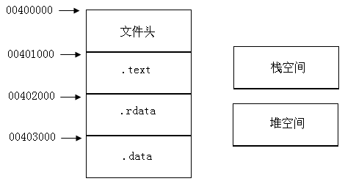
图附B-1 hello.exe逻辑运行空间设计
B.2 磁盘存储结构设计
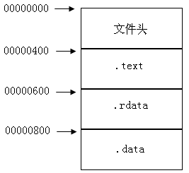
图附B-2 hello.exe磁盘存储结构设计
B.3 程序设计
⑴ 代码设计
；hWnd：指定该对话框的所有者窗口为0时，对话框不属于任何窗口
00401000 6A00 PUSH 00h ；对话框不属于任何窗口
；lpCaption：如果该参数为空（vbNullString），则使用默认的“错误”作为对话框的标题
00401002 6A00 PUSH 00h ；使用默认的对话框标题
；lpText: 显示在对话框中的消息
00401004 6800304000 PUSH 00403000h ；字符串“Helloworld”地址
；wType：指定显示按钮的数目及形式，使用的图标样式，缺省按钮是什么以及消息框的强制回应等
00401009 6A00 PUSH 00h ；按钮风格MB_OK
0040100B E808000000 CALL 00401018 ；显示对话框MessageBoxA()
；ExitCode: 返回码
00401010 6A00 PUSH 00h ；正常返回
00401012 E807000000 CALL 0040101E ；退出进程ExitProcess()
00401017 CC INT 3
⑵ 外部函授调用跳转接口设计
00401018 FF 25 08 20 40 00 ；jmp [00402008]
0040101E FF 25 00 20 40 00 ；jmp [00402000]
⑶ 程序设计结果
0000000400 6A 00 6A 00 68 00 30 40 00 6A 00 E8 08 00 00 00
0000000410 6A 00 E8 07 00 00 00 CC FF 25 08 20 40 00 FF 25
0000000420 00 20 40 00
B.4导入表设计
导入表设计的基本结构如附图B-3所示。
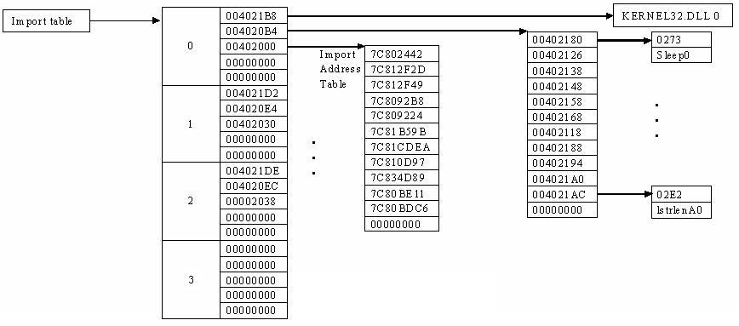
图附B-3 导入表的基本结构示例
⑴ 导入地址表IAT，即函数入口地址存储单元
00402000 76 20 00 00 00 00 00 00 ；函数ExitProcess()入口地址
00402008 5C 20 00 00 00 00 00 00 ；函数MessageBoxA()入口地址
⑵ user32.dll导入表IT
表B4-1 user32.dll导入表信息
逻辑地址 | 值 | 意义
00402010 | 00002054 | 函数查询信息入口
00402014 | 00000000 | 生成该结构的时间戳
00402018 | 00000000 | 第一个转发链的索引
0040201C | 0000206A | 动态链接库名称
00402020 | 00002008 | 函数入口地址的存储地址（RVA）

表B4-2 user32.dll导入函数信息
逻辑地址 | 值 | 意义
00402054 | 0000205C | 函数入口查询地址
00402058 | 00000000 | 导入函数信息结束结点
⑶ kernel32.dll导入表IT
表B4-3 kernel32.dll导入表信息
逻辑地址 | 值 | 意义
00402024 | 0000204C | 函数查询信息入口
00402028 | 00000000 | 生成该结构的时间戳
0040202C | 00000000 | 第一个转发链的索引
00402030 | 00002084 | 动态链接库名称
00402034 | 00002000 | 函数入口地址的存储地址（RVA）
表B4-4 kernel32.dll导入函数信息
逻辑地址 | 值 | 意义
0040204C | 00002076 | 函数入口查询地址
00402050 | 00000000 | 导入函数信息结束结点
⑷ 导入表结束结点设计
表B4-5导入表结束结点信息
逻辑地址 | 值 | 意义
00402038 | 000000000 | 函数查询信息入口
0040203C | 00000000 | 生成该结构的时间戳
00402040 | 00000000 | 第一个转发链的索引
00402044 | 00000000 | 动态链接库名称
00402048 | 00000000 | 函数入口地址的存储地址

⑸ 导入表查询信息
表B4-6导入表查询信息
逻辑地址 | 值 | 意义
0040205C | 01B1h | 函数线索，2字节
0040205E | MessageBoxA | 函数名称，以00结束
0040206A | user32.dll | 动态链接库名称，以0000结束
00402076 | 009Bh | 函数线索，2字节
00402078 | ExitProcess | 函数名称，以00结束
00402084 | kernel32.dll | 动态链接库名称，以0000结束
⑹ 导入表设计结果
00402000 76 20 00 00 00 00 00 00-5C 20 00 00 00 00 00 00
00402010 54 20 00 00 00 00 00 00-00 00 00 00 6A 20 00 00
00402020 08 20 00 00 4C 20 00 00-00 00 00 00 00 00 00 00
00402030 84 20 00 00 00 20 00 00-00 00 00 00 00 00 00 00
00402040 00 00 00 00 00 00 00 00-00 00 00 00 76 20 00 00
00402050 00 00 00 00 5C 20 00 00-00 00 00 00 B1 01 4D 65 ..............Me
00402060 73 73 61 67 65 42 6F 78-41 00 75 73 65 72 33 32 ssageBoxA.user32
00402070 2E 64 6C 6C 00 00 9B 00-45 78 69 74 50 72 6F 63 .dll....ExitProc
00402080 65 73 73 00 6B 65 72 6E-65 6C 33 32 2E 64 6C 6C ess.kernel32.dll
00402090 00 00 ..
B.5 提示信息的组织
提示信息按照GBK编码组织，以00h结束。本次实验只显示“HelloWorld”，生成的数据结果如下。
；第5扇区，.data段，GBK编码
00403000 48 65 6C 6C 6F 57 6F 72-6C 64 00 00 00 00 00 00 HelloWorld......
32 30 31 37 32 37 30 30-BA FA D1 C5 D4 B5
32 30 31 37 32 37 30 30-FA BA C5 D1 B5 D4

B.6 使用debug.exe生成hello.exe时使用的内存空间
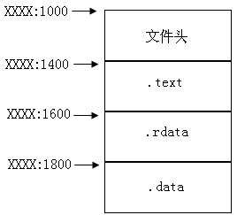
图附B-4 设计空间使用设计
附录C 实验答疑对应可执行文件的制作
1、批处理文件hello1.txt的制作
F 1000 L0A00 00

E 1000 4D 5A 90 00 03 00 00 00 04 00 00 00 FF FF 00 00
E 1010 B8 00 00 00 00 00 00 00 40 00 00 00 00 00 00 00
E 1030 00 00 00 00 00 00 00 00 00 00 00 00 B0 00 00 00
E 1040 0E 1F BA 0E 00 B4 09 CD 21 B8 01 4C CD 21 54 68
E 1050 69 73 20 70 72 6F 67 72 61 6D 20 63 61 6E 6E 6F
E 1060 74 20 62 65 20 72 75 6E 20 69 6E 20 44 4F 53 20
E 1070 6D 6F 64 65 2E 0D 0D 0A 24

E 10B0 50 45 00 00 4C 01 03 00 98 67 F8 51 00 00 00 00
E 10C0 00 00 00 00 E0 00 0F 01 0B 01 05 0C 00 02 00 00
E 10D0 00 04 00 00 00 00 00 00 00 10 00 00 00 10 00 00 ;程序入口EIP
E 10E0 00 20 00 00 00 00 40 00 00 10 00 00 00 02 00 00
E 10F0 04 00 00 00 00 00 00 00 04 00 00 00 00 00 00 00
E 1100 00 40 00 00 00 04 00 00 00 00 00 00 02 00 00 00
E 1110 00 00 10 00 00 10 00 00 00 00 10 00 00 10 00 00
E 1120 00 00 00 00 10 00 00 00 00 00 00 00 00 00 00 00
E 1130 10 20 00 00 3C 00 00 00 00 00 00 00 00 00 00 00
E 1180 00 00 00 00 00 00 00 00 00 20 00 00 10 00 00 00
E 11A0 00 00 00 00 00 00 00 00 2E 74 65 78 74 00 00 00
E 11B0 27 00 00 00 00 10 00 00 00 02 00 00 00 04 00 00 ;.text实际长度
E 11C0 00 00 00 00 00 00 00 00 00 00 00 00 20 00 00 60
E 11D0 2E 72 64 61 74 61 00 00 92 00 00 00 00 20 00 00 ;.rdata实际长度
E 11E0 00 02 00 00 00 06 00 00 00 00 00 00 00 00 00 00
E 11F0 00 00 00 00 40 00 00 40 2E 64 61 74 61 00 00 00
E 1200 24 00 00 00 00 30 00 00 00 02 00 00 00 08 00 00 ;.data实际长度
E 1210 00 00 00 00 00 00 00 00 00 00 00 00 40 00 00 C0

E 1400 6A 00 68 10 30 40 00 68 00 30 40 00 6A 00 E8 08 ;正常文件代码
E 1410 00 00 00 6A 00 E8 07 00 00 00 CC FF 25 08 20 40 ;外部函数接口
E 1420 00 FF 25 00 20 40 00

E 1600 76 20 00 00 00 00 00 00 5C 20 00 00 00 00 00 00
E 1610 54 20 00 00 00 00 00 00 00 00 00 00 6A 20 00 00
E 1620 08 20 00 00 4C 20 00 00 00 00 00 00 00 00 00 00
E 1630 84 20 00 00 00 20 00 00 00 00 00 00 00 00 00 00
E 1640 00 00 00 00 00 00 00 00 00 00 00 00 76 20 00 00
E 1650 00 00 00 00 5C 20 00 00 00 00 00 00 B1 01 4D 65
E 1660 73 73 61 67 65 42 6F 78 41 00 75 73 65 72 33 32
E 1670 2E 64 6C 6C 00 00 9B 00 45 78 69 74 50 72 6F 63
E 1680 65 73 73 00 6B 65 72 6E 65 6C 33 32 2E 64 6C 6C
E 1690 00 00

E 1800 48 65 6C 6C 6F 57 6F 72 6C 64 00 ;窗口提示信息
E 1810 50 72 6F 67 72 61 6D 20 49 6E 66 6F 72 6D 61 74 ;窗口标题
E 1820 69 6F 6E 00

N c:\h1.dat
R BX
0
R CX
0A00
W 1000
Q
2、h1.exe的获得
2.1 执行批处理文件，生成数据文件h1.dat。
debug < hello1.txt
2.2 复制数据文件，生成可执行文件h1.exe。
copy h1.dat h1.exe
2.3 运行新生成的可执行文件，运行效果如图附C-1所示。
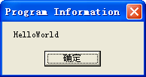
图附C-1 修改后程序运行效果

